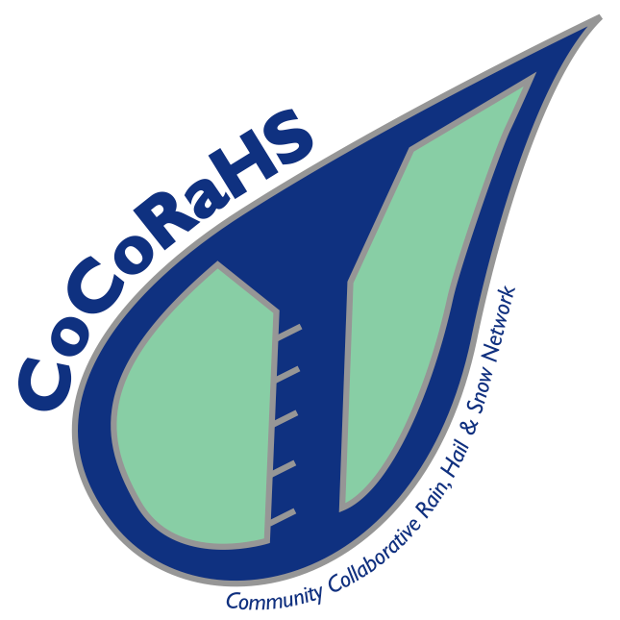

Through the Community Collaborative Rain, Snow, and Hail Network (CoCoRaHS), citizen scientists measure and map precipitation. Data are used by the National Weather Service, meteorologists, hydrologists, engineers, farmers and ranchers, and others.

A Guided Tour:

Step 1. Begin by taking a look at the CoCoRaHS homepage to get a sense of the project. | http://www.cocorahs.org/
Review the list of groups that use the data collected. | http://www.cocorahs.org/Content.aspx?page=CoCoRaHS_Data_Users

Step 2. Read about how citizen scientists collect data as part of the CoCoRaHS project. Think about how you, as a teacher, might be able to connect this project to your curriculum. | http://www.cocorahs.org/Media/docs/CoCoRaHSBrochure2010_FINAL.pdf

Step 3. View the video that shows how schools can participate. What would you need to do in order to prepare your students? How would you acquire the measurement tools? (rain gauge and/or hail pad) | http://www.cocorahs.org/Content.aspx?page=CoCoRaHS_Schools

Step 4. Examine the data collection forms students would use. What support might your students require to collect and report data using these forms? | Rain/snow form:  http://www.cocorahs.org/media/docs/rainsnowform_2010.pdf  Hail form:  http://www.cocorahs.org/media/docs/Hail_Card.pdf

Step 5. Look at the daily precipitation report data (full dataset). What questions could students investigate using this data? | http://www.cocorahs.org/ViewData/ListDailyPrecipReports.aspx
Look at the map of data collected for the state of Maryland. What questions could students investigate using this data? | http://data.cocorahs.org/cocorahs/maps/?country=usa&state=md

If you have time, browse the lesson plans available to educators through CoCoRaHS: http://www.cocorahs.org/Content.aspx?page=CoCoRaHS-Schools-Teachers

