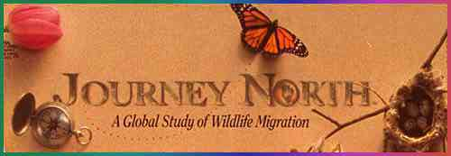

Through Journey North, citizen scientists collect data about monarch butterfly migration across North America. These data can help the public and scientists to understand how butterfly populations are changing, particularly how they have declined over the past decade.

A Guided Tour:

Step 1. Begin by taking a look at the Journey North homepage to get a sense of the project. | https://www.learner.org/jnorth/monarch/

Step 2. Browse the background information the project provides about monarch migration. What kinds of background information would help your students collect data about monarch butterflies? What science topics in your curriculum might relate to butterfly migration? | https://www.learner.org/jnorth/tm/monarch/jr/IntroMig.html

Step 3. Read about the types of butterfly information citizen scientists report during the Fall season. Can you think of a place that your students could go to collect these kinds of data? (note that the data reporting requires the teacher to log in) | https://www.learner.org/jnorth/tm/monarch/FallWatch.html

Step 4. Look at the map of monarch migration data reported so far for Fall 2015. What questions could your students investigate by examining the map? | https://www.learner.org/jnorth/maps/monarch.html
What could they investigate by using the data archives to compare this season to past years? | http://www.learner.org/jnorth/maps/archives.html

If you have time, browse the teaching suggestions for educators: https://www.learner.org/jnorth/tm/monarch/ExpertTS.html

